**Lockers Pvt Ltd Project**

The project is developed by Neeti Kulkarni.

**Agile Sprints**

|  |  |  |  |
| --- | --- | --- | --- |
| **Sprint No** | **Day** | **Work Planned** | **Work Status** |
| **1** | **1** | **Analyse the problem** | **Completed Analysis** |
|  | **2** | **Started coding for Display module** | **Completed** |
|  | **3** | **Started coding on Adding module** | **Completed** |
|  | **4** | **Started coding on Delete module** | **Completed** |
|  | **5** | **Started coding on Searching module** | **Tested** |
| **2** | **6** | **Searching module completed** | **Completed** |
|  | **7** | **Combining all modules with the help of switch** | **In progress** |
|  | **8** | **All modules combined** | **Completed** |
|  | **9** | **Working on while loop to make the program appropriate to control the flow of choices in program** | **In progress** |
|  | **10** | **Working on while loop to make the program appropriate to control the flow of choices in program** | **Completed** |

**Flowchart**

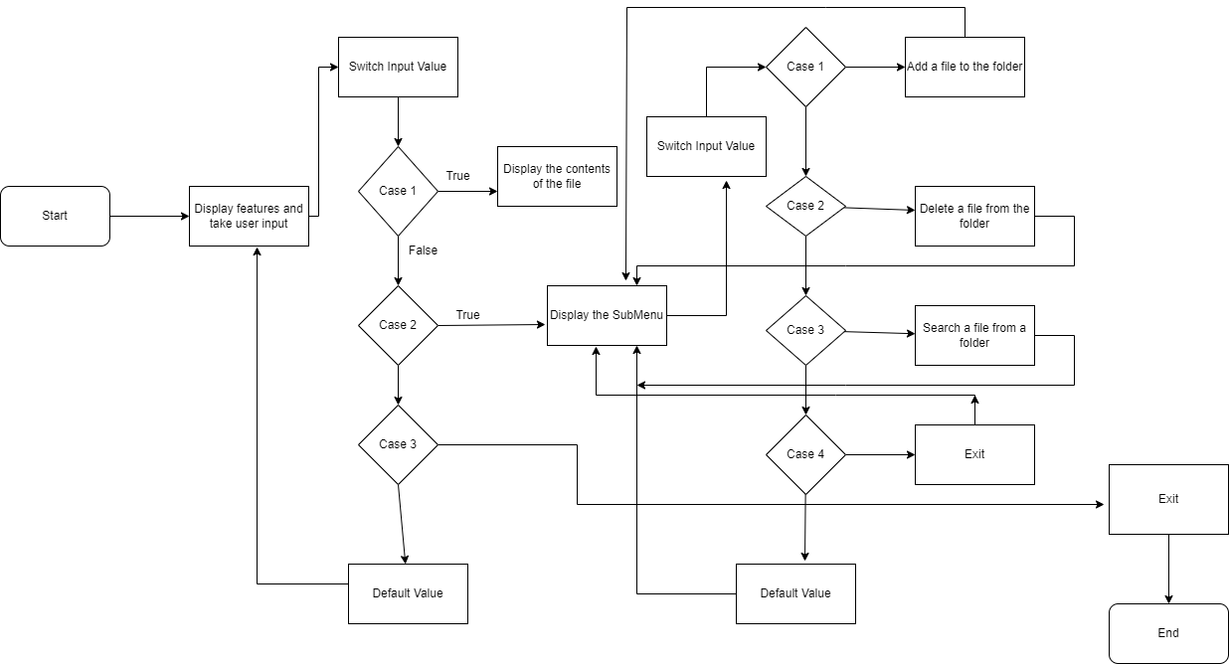

**Core Concepts Used in Project:**

File handling, Flow control, Sorting, Flow Control, Array List, File Streams, Objects, Methods.

**Link of Github**

[**https://github.com/Neeti-Kulkarni/Weekend-JavaFSD-27-8**](https://github.com/Neeti-Kulkarni/Weekend-JavaFSD-27-8)

**USP**

The user is able to switch between options or return to previous menu even after any required operation

Like adding, searching, deleting or retrieving of files.

The application allows user to add, delete, search and display files.